Ref. No: Date: 02.08.2023

Notice Regarding 6th Semester Programme Practical Exam
It is hereby notify to all 6th semester programme students that CHEMGPDSE-2 will be held on 16th August (group A) & 17th August (group B), 2023. Exam Time - 10:30am-12:30pm. Reporting time: 10:15am. All students must attain positively with their necessary practical items, lab note book, and apron, calculator and admit cards.
Group A: Univ. Roll No: 2314127-2040844 to 2314127-2040899
Group B: Roll No: 2314127-2040900 to remaining all students
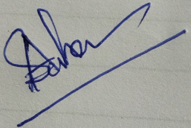

HOD
Department of Chemistry

